Contents

1) Create Log Analytics WorkSpace: 2

2) Configure VMInsights for the Workspace 3

3) Install Log Analytics agents on the virtual machine 8

Additional Information: 11

Refrences : 13

# Create Log Analytics WorkSpace:

*Create a Log Analytics Workspace in the Central US region. Ensure that the workspace has the Log Analytics Contributor Role.*

-Search for Log Analytics Workspaces and create Log Analytics workspace as below

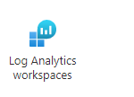

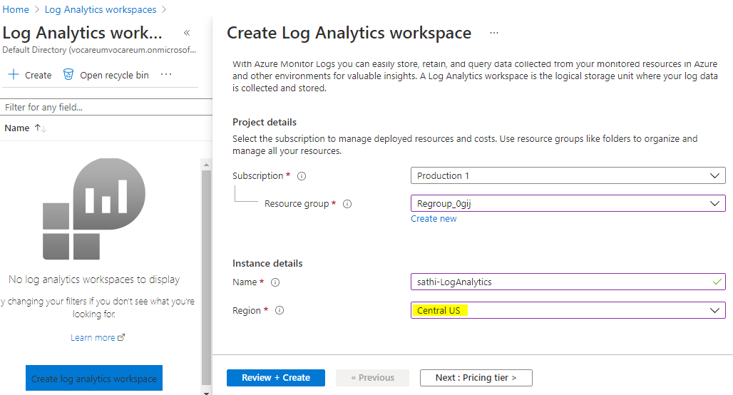

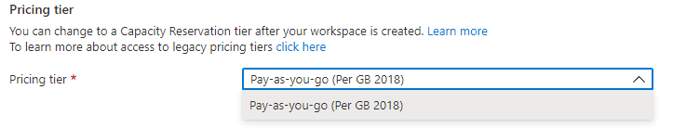

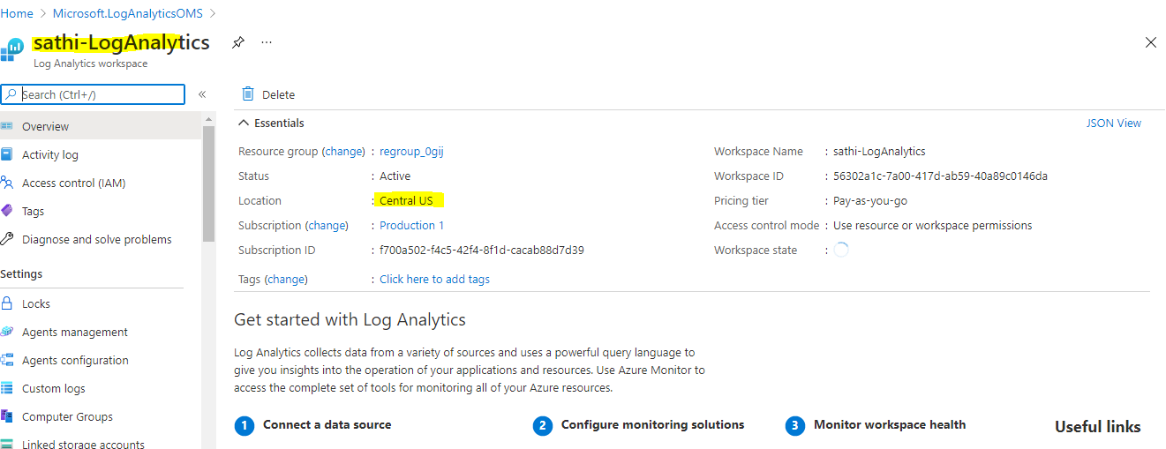

*Contributor Role verification*

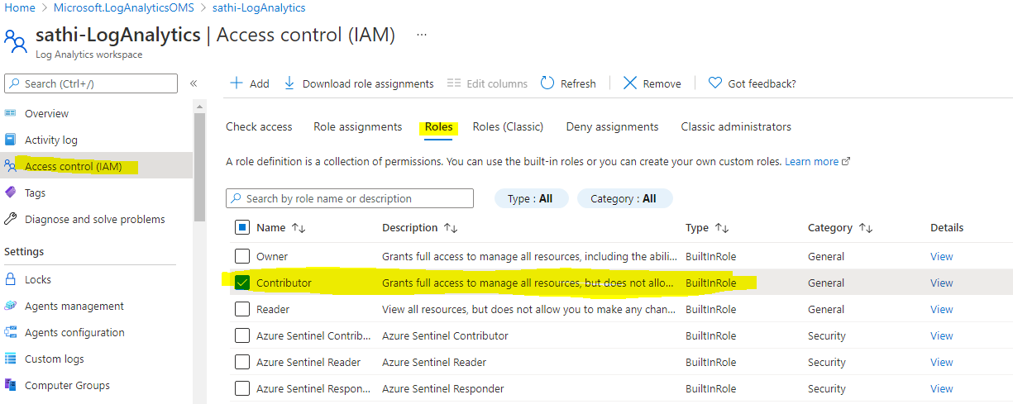

# Configure VMInsights for the Workspace

Add VM Insights to the workspace created to enable all VMs to send data to

Insight Metrics

Create VM1

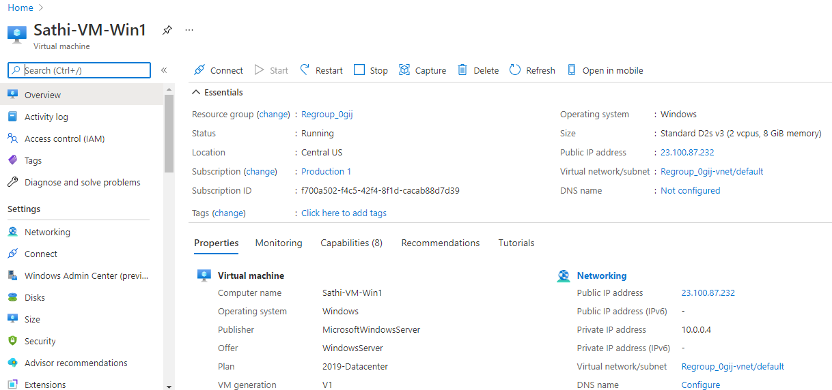

*Go to VM Insights and Enable the log anayltics work space created above*

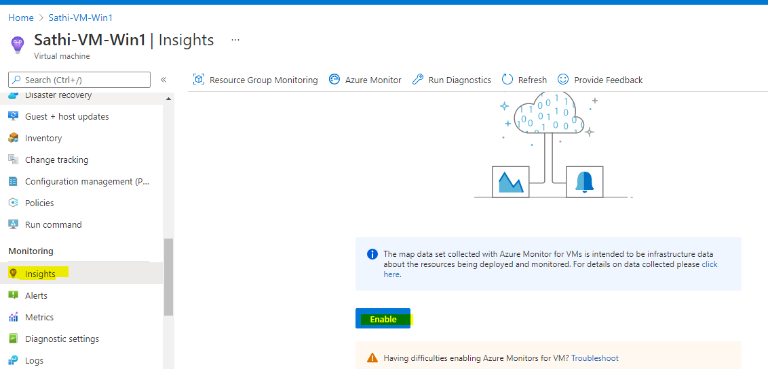

*Select log analytics created in earlier step*

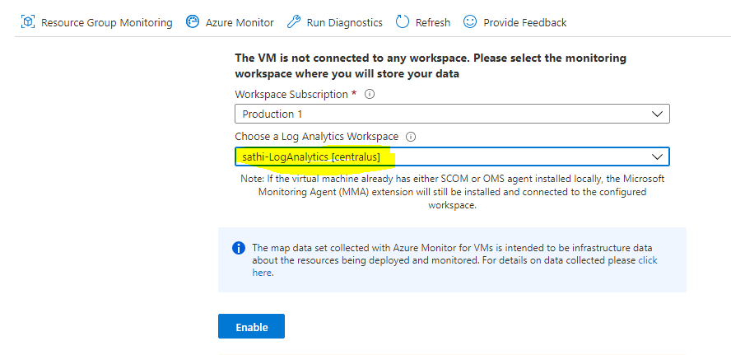





Login to verify VM and do some activity

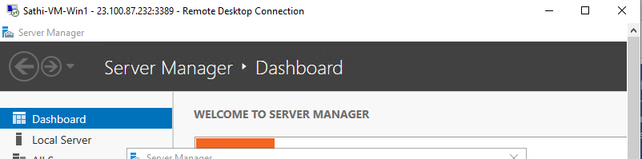

*We can view all the fundamental VM insights*  
*==> From Virtual Machine =>Insights Path*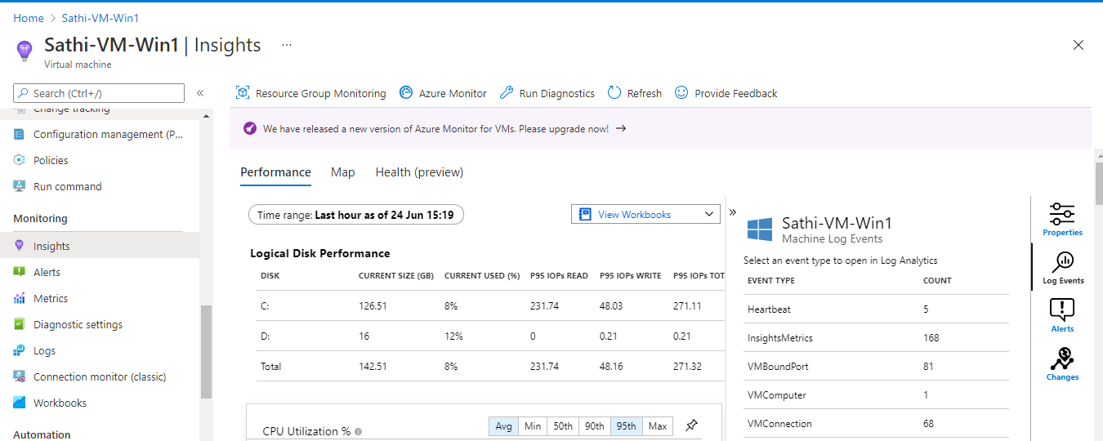

*==> From Monitor path : Monitor==>Virtual machines*

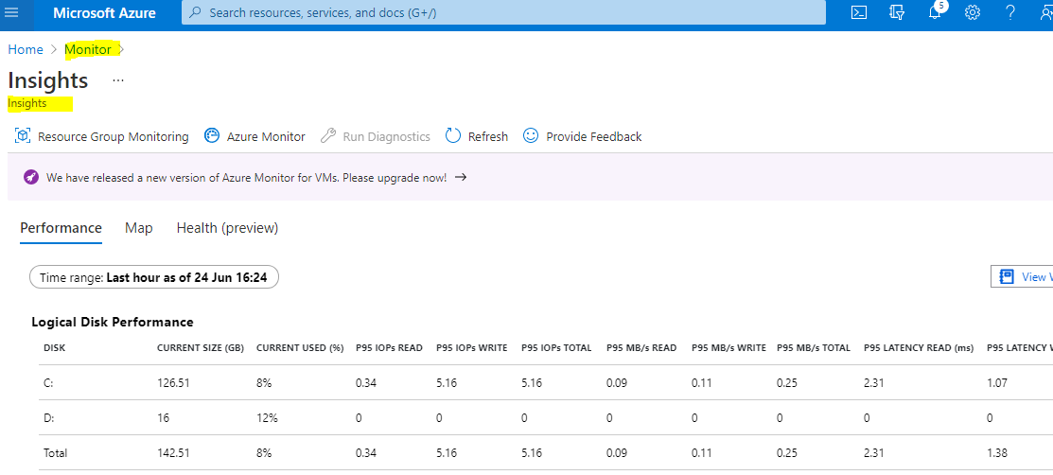

Connect VM – LogAnylatics  
-The above VM is connected to Log Analytical Workspace as we enabled in earlier step, if not naviagate to Log analytics workspace data sources , click on virtual machines and select the machine to connet/disconnect

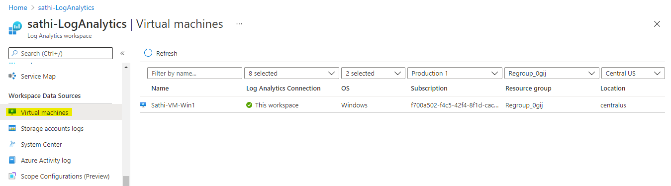

 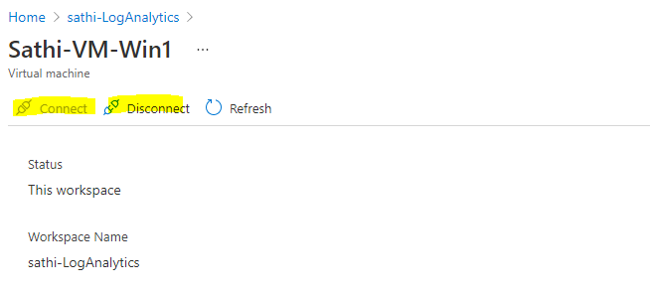

*Agent can be downlaoded manually and installed on any required machine*  
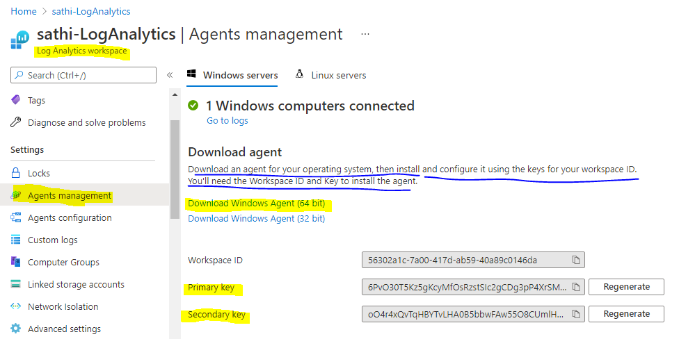

*Windows Events Logs Configuration :*

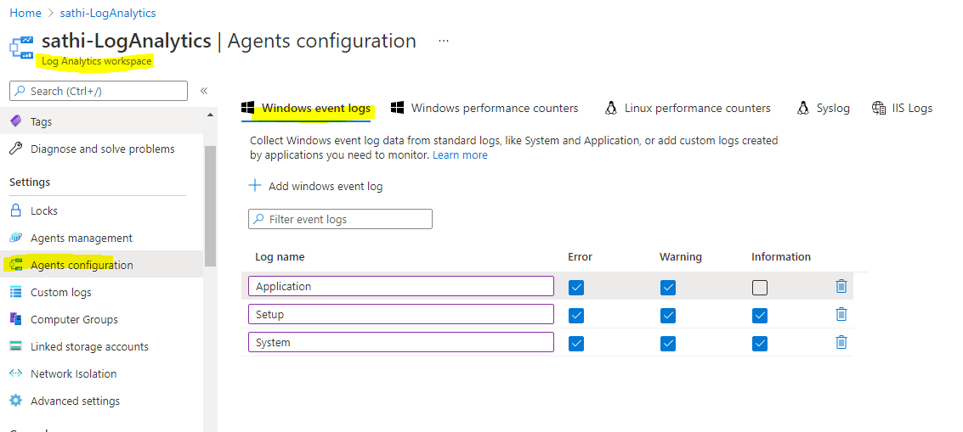

*Enabling Performance Counters :*

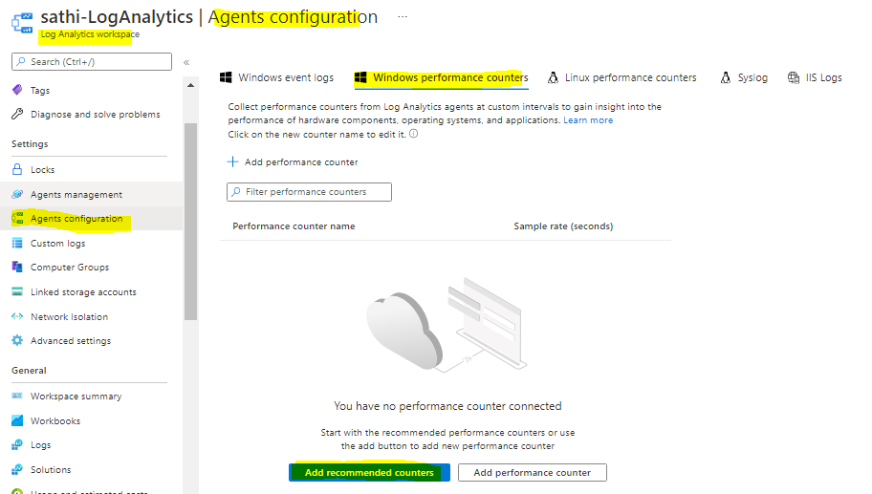

*Query the above applied/enabled logs using KQL*

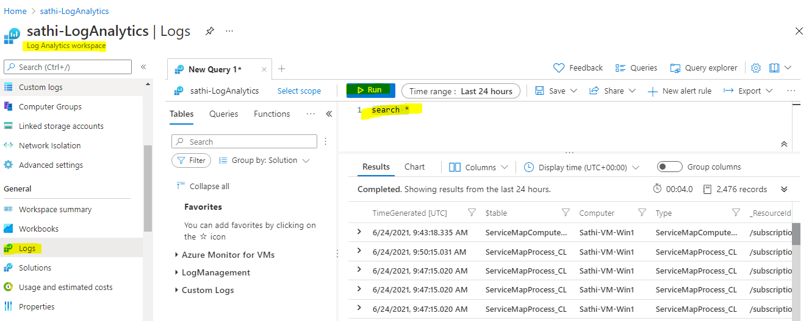

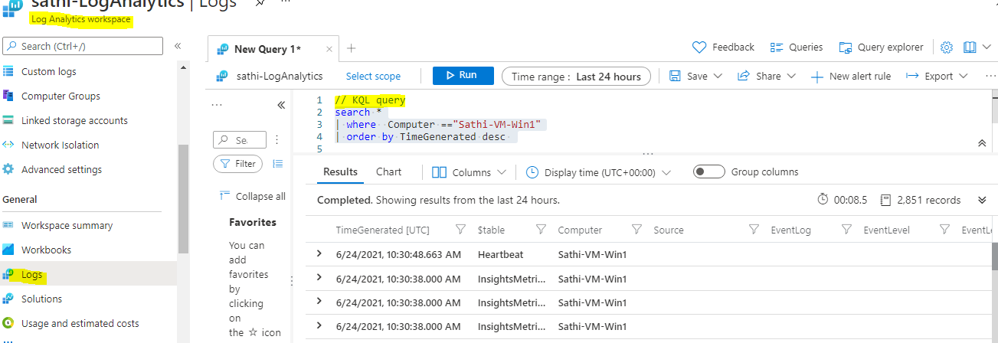

# 3) Install Log Analytics agents on the virtual machine

Install the Dependency Agent on the VM following OS-specific instructions

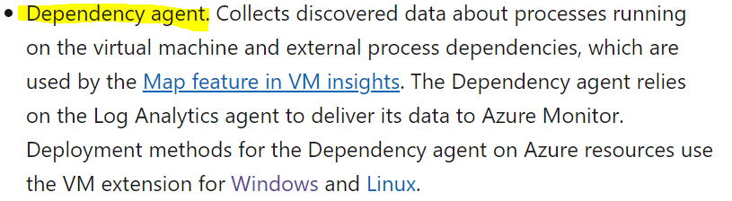

*ARM template for dependency agent Microsoft.Azure.Monitoring.DependencyAgent deployment in VM machine -json template*

{

"$schema": "https://schema.management.azure.com/schemas/2015-01-01/deploymentTemplate.json#",

"contentVersion": "1.0.0.0",

"parameters": {

"vmName": {

"type": "string",

"metadata": {

"description": "The name of existing Azure VM. Supported Windows Server versions: 2008 R2 and above (x64)."

}

}

},

"variables": {

"vmExtensionsApiVersion": "2017-03-30"

},

"resources": [

{

"type": "Microsoft.Compute/virtualMachines/extensions",

"name": "[concat(parameters('vmName'),'/DAExtension')]",

"apiVersion": "[variables('vmExtensionsApiVersion')]",

"location": "[resourceGroup().location]",

"dependsOn": [

],

"properties": {

"publisher": "Microsoft.Azure.Monitoring.DependencyAgent",

"type": "DependencyAgentWindows",

"typeHandlerVersion": "9.5",

"autoUpgradeMinorVersion": true

}

}

],

"outputs": {

}

}

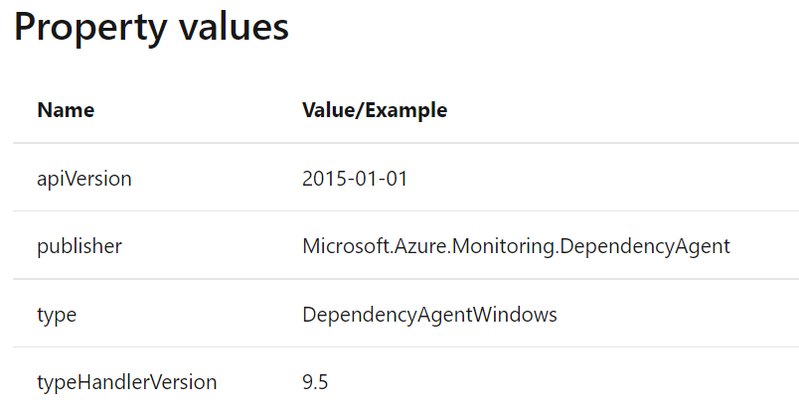

Create VM 2 , by deafult no extensions are deployed (vm==>Extensions)

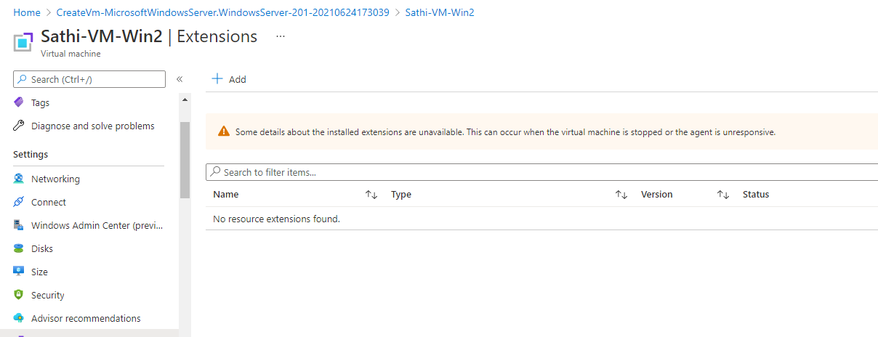

Deploy the above ARM template

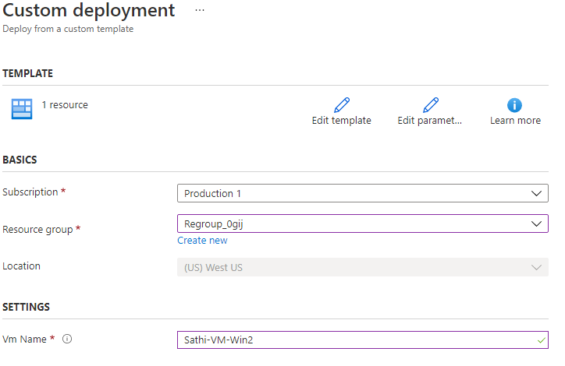

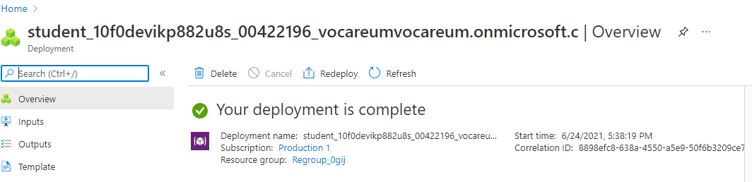

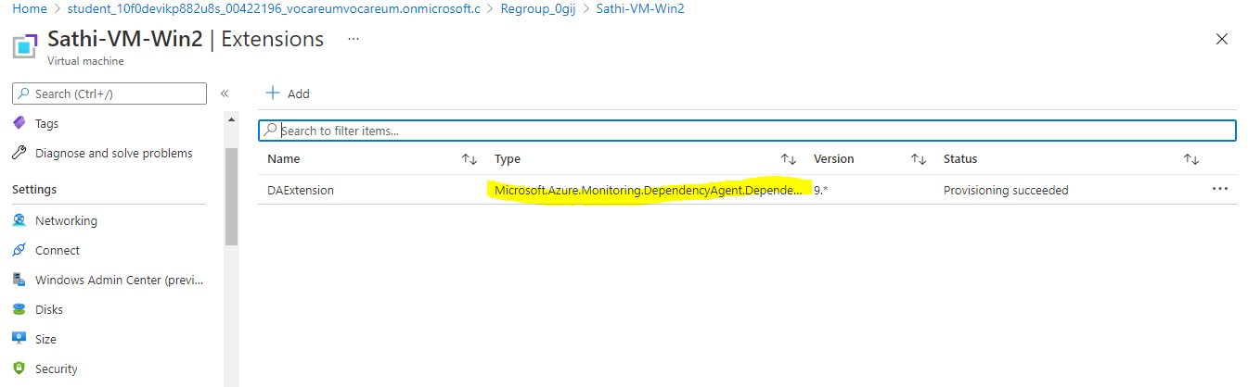

-----------------------------------Assignment END-----------------------------------------------------------------------------

# Additional Information:

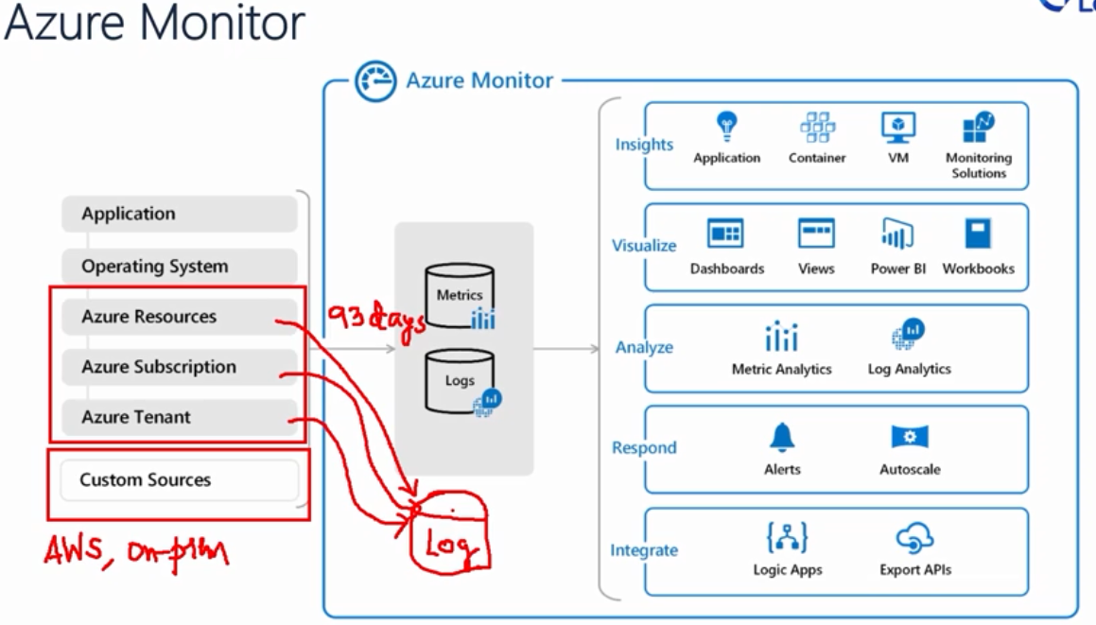

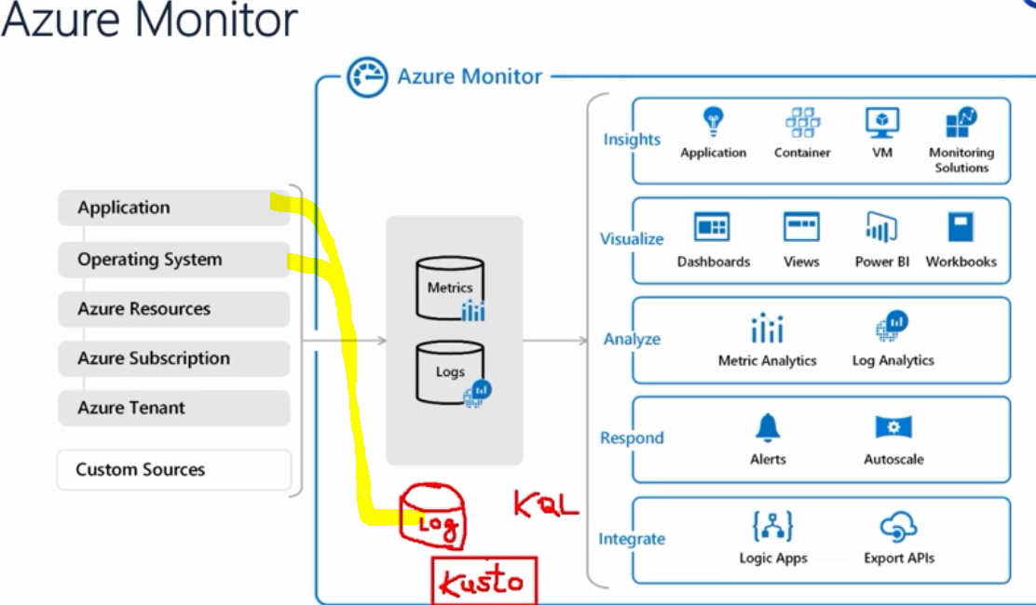

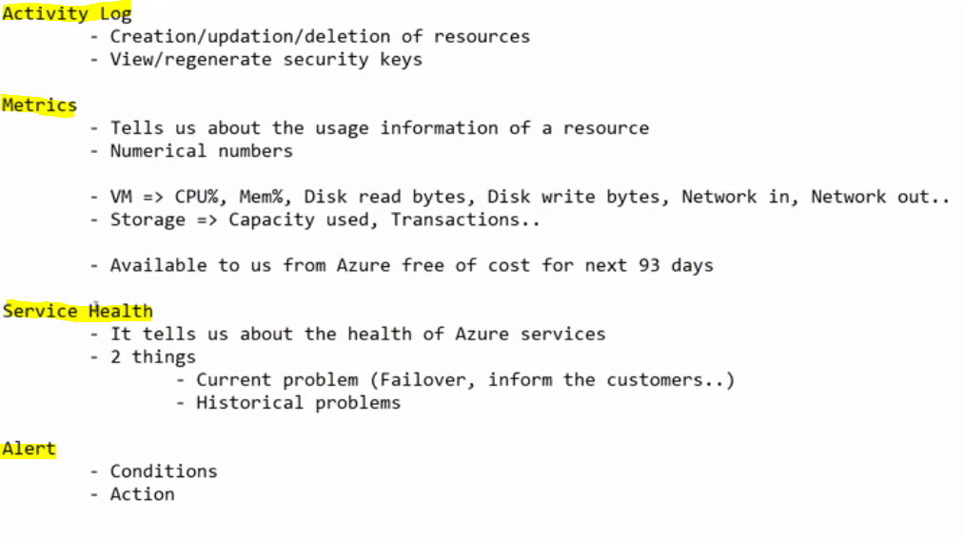

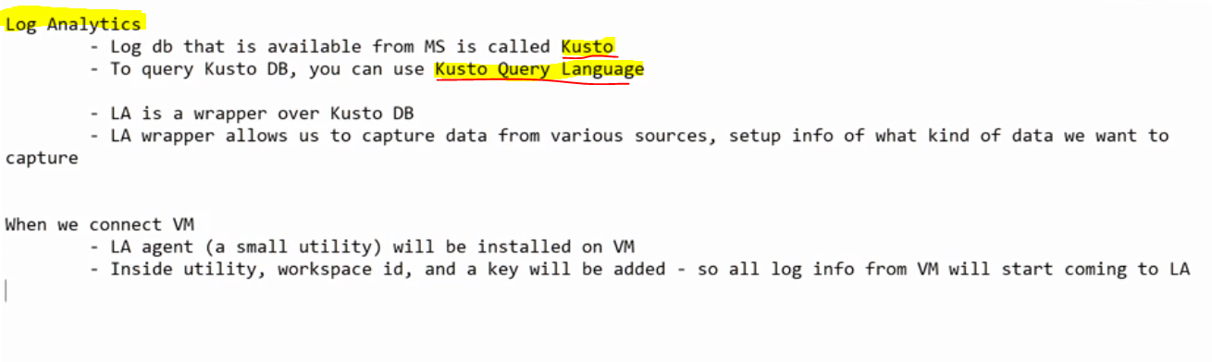

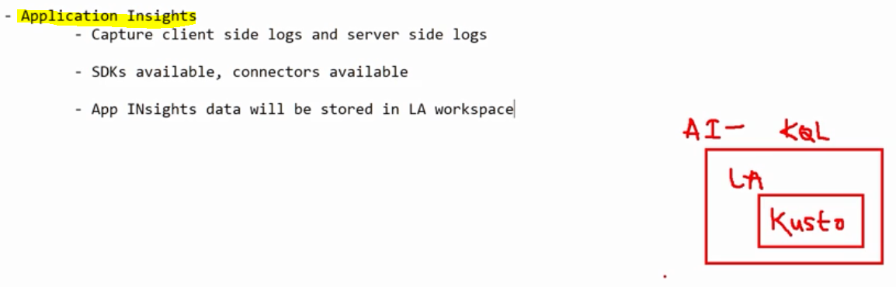

Monitor is free and available for around only 93 days history , Log Analytics needs to be used if we need to have data for more then 93 days

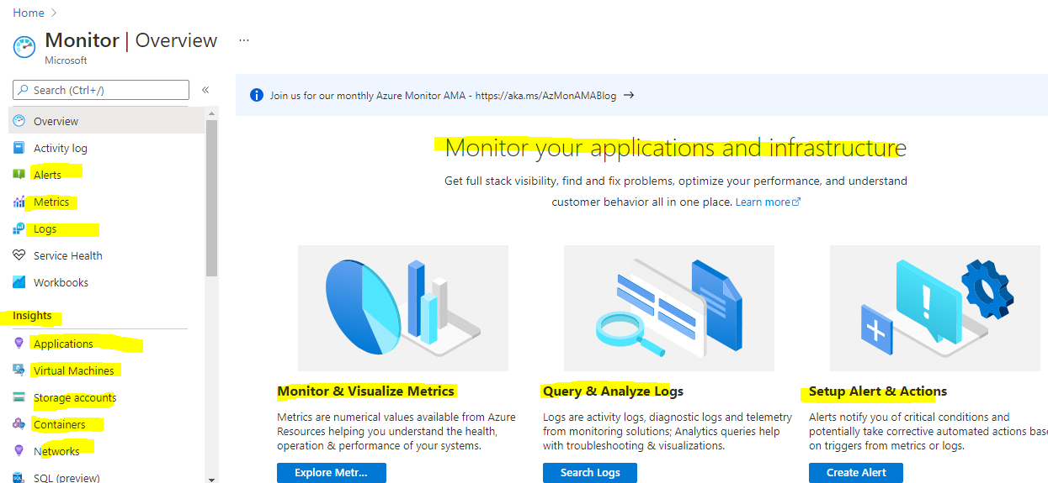

# Refrences :

<https://docs.microsoft.com/en-us/azure/azure-monitor/vm/vminsights-overview>

<https://docs.microsoft.com/en-us/azure/azure-monitor/logs/quick-create-workspace>